There are two parts to the exam. The first part is the short answer, second is an essay.
Part 1.
Answer the following questions using short answers (5 sentences maximum). Some questions may even be successfully addressed with a single sentence answer.
Questions:
Explain size-weight illusion and give an example of where it may occur in real life.

How does rotational inertia of the object affects it’s perceived length?

What did Gibson mean by terms “exteroception”, “proprioception”, and “exproprioception”?

What phenomena does the Haken-Kelso-Bunz (HKB) equation describe?

Using an example from one of the studies that we discussed in class, describe what is hysteresis effect in a dynamical system. You can also draw an illustration if needed.

When we discussed coordination dynamics, I talked about the principle dynamical similitude. What is that principle and how has it been used in psychology?

Name two features of self-organization.

Describe the logic of the Donders’s subtractive method.

What is component-dominant dynamics and how is interaction-dominant dynamics different?

During the last semester, a student sent thousands of text messages, wrote hundreds of short answer essays, and a couple of term papers. Sketch the likely distribution of word text lengths in her writing pattern. What is this distribution called?

Given the following attractor landscape, 1) identify the attractors and repellers present in this system, 2) which one of the attractors is stronger?
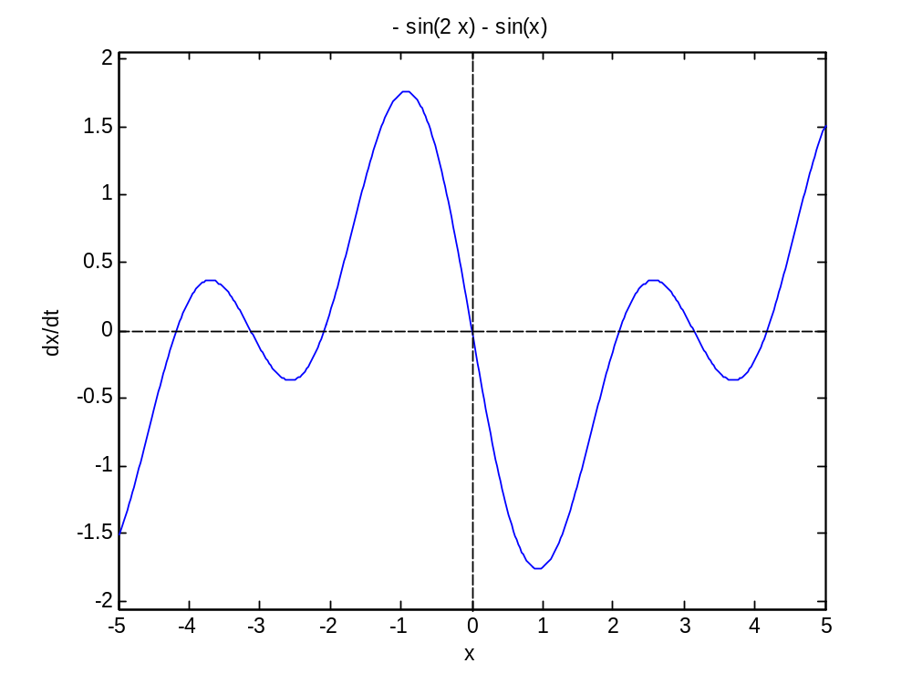

Name at least two insights from our exercise in bathtub dynamics with regard to understanding of complex dynamical systems.

Define a dynamical system and provide an example.

Part 2. Essay
Address one of the questions below for the last portion of the exam. Your answer should be logically written text consisting of several paragraphs (introduction, main body, and a conclusion).
Questions:
We have frequently talked about the uses of physical analogies in psychology. Write a position statement arguing either in favor or against the use of such analogies in psychology. Please remember that at issue is how to move psychology forward and what strategy to use to develop new experiments. Think of the history too and the other approaches to perception-action phenomena that researchers have used.

Describe the concept of perception-action cycle in the context of dynamic touch experiments discussed in class. Make sure to define all relevant terms and explain concepts.

